<meta charset="UTF-8">

<meta name="viewport" content="width=device-width, initial-scale=1.0">

<!-- <meta name="description" content="This is an example webpage showcasing different meta tags.">

<meta name="author" content="John Doe">

<meta name="robots" content="index, follow">

<!-- <meta http-equiv="refresh" content="5;url=https://example.com"> -->

<!-- Open Graph Meta Tags (for social media sharing) -->

<meta property="og:title" content="Example Website">

<meta property="og:description" content="A demo website for Open Graph meta tags">

<meta property="og:image" content="https://example.com/images/preview.jpg">

<!-- Apple Devices Meta Tags -->

<meta name="apple-mobile-web-app-capable" content="yes">

<meta name="apple-mobile-web-app-title" content="Example"> -->



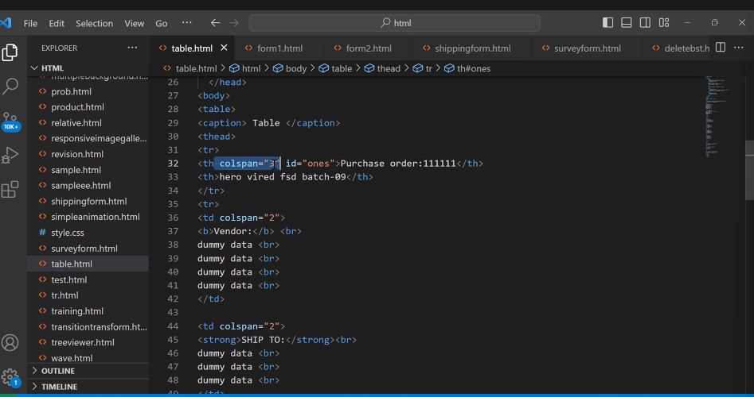

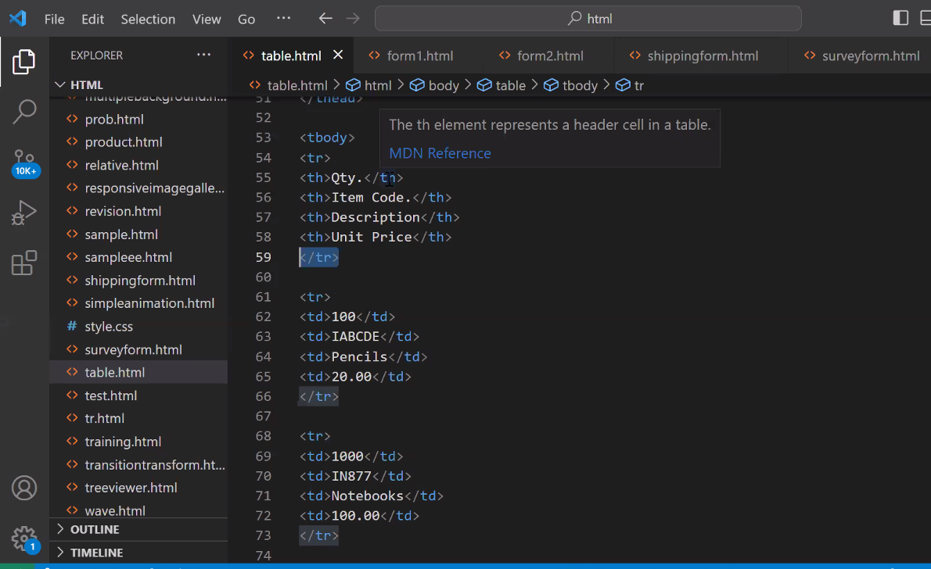

Batch 10 Git hub link:

<https://github.com/snehal-herovired/FSD_BATCH_10>

slack link:

<https://join.slack.com/t/hackthevired/shared_invite/zt-22j8r0wvm-baW1VNptWTNdMB~5HzF6Dg>

<https://weblearnbd.net/tphtml/educal/educal/index-2.html>

<https://getbootstrap.com/docs/5.2/examples/footers/>

fontawesome link: <link rel="stylesheet" href=<https://cdnjs.cloudflare.com/ajax/libs/font-awesome/4.7.0/css/font-awesome.min.css>

<link rel="stylesheet" href="https://cdnjs.cloudflare.com/ajax/libs/font-awesome/4.7.0/css/font-awesome.min.css ">

**transform: matrix**(a, b, c, d, e, f);a (m11): Represents the horizontal scaling.b (m12): Represents the vertical skewing.c (m21): Represents the horizontal skewing.d (m22): Represents the vertical scaling.e (m41): Represents the horizontal translation (movement along the X-axis).f (m42): Represents the vertical translation (movement along the Y-axis).

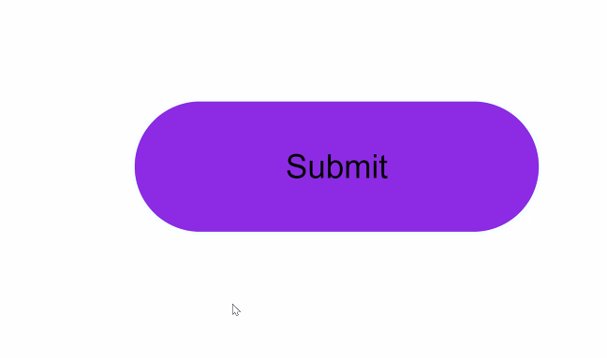



Linear gradient:



-

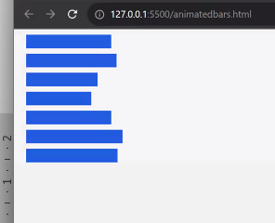

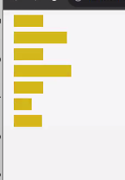 width & color to be change at every % of change in width.

<https://getbootstrap.com/docs/5.3/examples/>

DCS: 22-09-23



-

